Application Form for
Darnall Well Being
Helping the people of Darnall and Tinsley stay healthy

Volunteer Coordinator
or
Community Development Manager
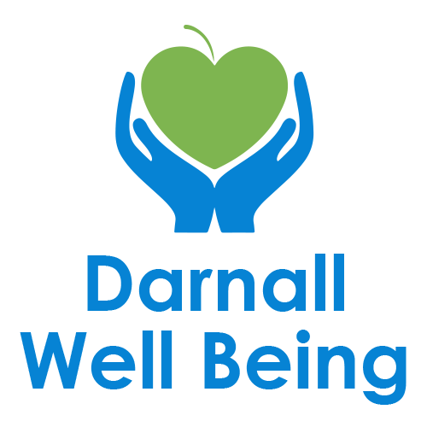

Closing Date: Midnight, Sunday 21 June 2026
Completed form to be returned to dwb.enquiries@darnallwellbeing.org.uk

Guidance notes for completing your application form
It is our intention to appoint the best candidate for every vacancy and to do this fairly we need all applicants to provide relevant information about themselves. This information should relate directly to the requirements of the job, which are listed in the Person Specification and which are regarded as essential in order to work effectively in post.

Your application form should provide us with as much relevant information as possible. You should not assume that the interview panel will be familiar with the type of work/activities you have experienced in the past and, therefore, you should provide detailed information.

Please complete all sections of the form. It may be helpful to do a rough draft first. Please write as clearly as possible. Also use extra sheets of paper if needed.

Section 4 asks for relevant skills, qualifications and training. We do not need a full account of your education here, but please mention qualifications and/or training which are necessary or relevant (if any) to the job.

Section 5 Supporting Statement, why you think you are suitable for the job is the most important part of the form. You should refer to the Job description and Person Specification and provide detailed information under appropriate headings or in appropriate paragraphs so we can make an assessment of your suitability. The trick is to demonstrate how you fulfil the person specification – you need to prove your suitability, not just state it.

Please do not send Curriculum Vitae (CV) with your application as it will not be counted towards your application.

Job Applying for - please highlight
Volunteer Coordinator Community Development Manager

Personal Details
Title: | Surname/Family Name: | First Name(s):

Address: | Phone Number:  Email:  Preferred method of contacting:
Right to work in the UK YES/NO | Do you have a full UK driving licence?  Do you have access to a mode of transport for work purposes? (Only include if it is genuinely essential.)

- Employment & Voluntary Work

Please give details of your present or most recent job
Job Title:
Employer’s name and address:

Start and end date:
Salary:
Length of notice required:

Employment History
Please provide full details of your employment and activities since leaving full time education.
This should include any periods not covered by paid employment, education or training (for example: unemployment,
voluntary work, raising a family, part‑time work). Add additional rows if needed.
Name of Employer  & Address | Date  From To | Job title and brief outline of duties | Reason for leaving

- Skills / Qualifications / Training
Please give details of any qualifications obtained and training courses undertaken which are relevant to the
job together with dates.
*Add more rows if necessary
Qualifications / Training & Institution | Grades / Results | From | To

- Supporting Statement
Please use this section to explain how your skills, experience and values make you a strong match for this role. Refer to the job description and person specification when answering.

reasons

(Continue on additional sheets if necessary)

- Further Information

Do you have any criminal convictions (other than spent convictions), cautions or pending prosecutions? YES / NO (delete as appropriate)
If ‘YES’ please give details

Adjustments and Accessibility
We want to ensure an inclusive and accessible recruitment process.

Do you require any adjustments for interview / practical tasks?

If yes please provide details:

Relationships / Conflict of Interest

Darnall Well Being must ensure a fair and transparent recruitment process.

Do you have any personal, family, or close working relationship with anyone connected to DWB (e.g. employee, volunteer, Trustee)?

If yes, please give their name and the nature of your relationship

For information, could you please let us know where you saw this post advertised.

REFERENCES – Please give names and addresses of two people who we can contact for references.
Referee (1) Should be your present or more recent employer
Referee (2) Could be either personal or employment related

Referee 1: | Referee 2:
Name: | Name:
Address:  Tel No:  Email address: | Address:  Tel No:  Email address:
May we contact this person prior to your interview  YES / NO (delete as appropriate)  Capacity in which s/he is being approached:  Employment / Personal Referee (delete as applicable) | May we contact this person prior to your interview  YES / NO (delete as appropriate)  Capacity in which s/he is being approached:  Employment / Personal Referee (delete as applicable)

Data Protection Statement
Darnall Well Being will use the information provided in this application form for recruitment and selection purposes only. Your data will be stored securely and only shared with staff involved in the recruitment process. If you are unsuccessful, your data will be retained for 6 months and then securely destroyed. By submitting this form, you consent to the processing of your data for these purposes.

Equality Diversity and Inclusion Monitoring Form (separate document) We would be grateful if you could also complete this separate monitoring form to support our commitment to fair and inclusive recruitment.

Availability for Interview - We have stated the dates of interviews on the job advert. Please state if you are unavailable on these dates for interview

DECLARATION
I confirm that the information provided in this application is true and complete. I understand that any false statement or omission may lead to withdrawal of an offer or dismissal if appointed.

Signature: …………………………………..…… | Date: ……………………………

