Darnall Well Being
Wellbeing Champions

“Becoming a volunteer was life changing for me”.

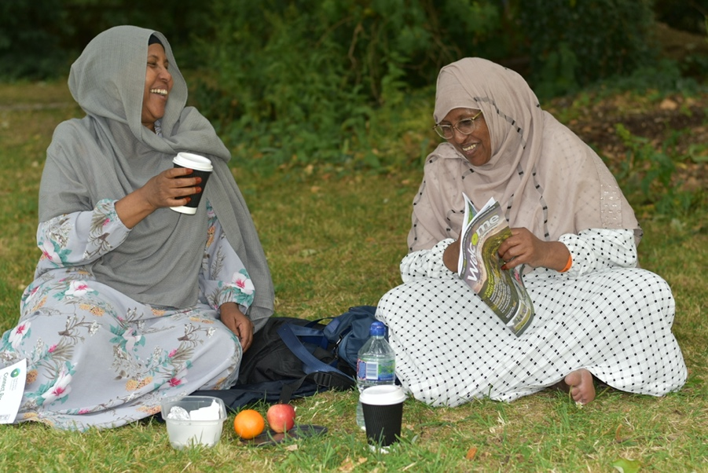

A National Lottery Reaching Communities Funded Programme
Independent evaluation March 2025

Kate Quail MPH, FRSPH

INTRODUCTION
This report provides an independent evaluation of the Reaching Communities funded Darnall Well Being (DWB) Wellbeing Champions volunteer programme and its support for local communities.

It provides an outline of the needs of local communities, many of which are not currently being met by other services. It looks at how DWB Wellbeing Champions are meeting these needs and describes the impact of the programme so far.

It details the Programme and wide range of activities provided and describes the benefits for the volunteers, beneficiaries, the wider community, DWB and other organisations.

The report summarises the learning, challenges and successes of the Programme and makes recommendations regarding the need to develop new aspects to the programme, focusing particularly on supporting young people.

THE EVALUATION
The evaluation has gathered data through one-to-one and group interviews with:
- 55 people attending 5 different of DWB activity groups – Chairobics, English Conversation Group, Women’s Yoga, Monday Health Walk, Craft Group
- Wellbeing Champions and Peer Mentor volunteers
- Volunteer Coordinator
- Communications Coordinator
- DWB staff

The interviewer also took part in each activity group, carrying out activities with the other attendees. It was notable that group attendees were more willing and happier to be interviewed after they had shared the group experience together.
Feedback has also been gathered throughout the life of the Programme through videos, survey forms and comment sheets completed by volunteers and beneficiaries. (Evaluation survey forms are available on request). All quotes are from Wellbeing Champions, Peer Mentors and beneficiaries gathered through interviews as part of this evaluation, or as otherwise shown.

Headline results
This evaluation found that the Project achieved outstanding results. As a result of being a volunteer or beneficiary attending DWB groups and activities:

100% volunteers and beneficiaries feel less isolated and better connected
100% feel their self-esteem has improved and report feeling more in control
100% feel they have better access to support and services
100% report having increased knowledge, confidence and skills relating to getting fit and staying healthy
100% feel more confident that their area is a good place to live
100% say they are more confident and able to socialise with people from different communities.

LOCAL CONTEXT
Darnall Ward is in the top 10% of the most deprived communities in the country.

Health inequalities The Darnall neighbourhood (within the Ward) is the third most deprived neighbourhood in Sheffield, experiencing higher than the city’s average levels of ill-health, poverty and low health literacy. Many of the local communities feel disempowered and experience disadvantage and discrimination.
Deprivation - The Index of Multiple Deprivation 2019 shows that 70.3% of people in Darnall are living in the most deprived 20% of areas of England (average = 20.0%). (source Local Insight profile, Sheffield City Council, 2024). This is particularly notable in the following domains:
- Income deprivation - 77.2% (England average = 20.0%)
- Employment deprivation - 63.7% (England average = 19.5%)
- Education deprivation - 83.6% (England average = 19.8%)
- Health deprivation - 63.7% (England average = 19.6%)
47% children aged 0-19 are in relative low-income families in Darnall compared with 20% across England.

Education and employment 34% people aged 16+ have no qualifications in Darnall compared with 18% across England and Darnall has higher levels of youth unemployment aged 18 to 24 - 11.1%; England average 5% (Source Local Insight profile for Darnall ward, Sheffield City Council Report February 2024).

Physical inactivity - 34% of adults in Darnall are physically inactive: undertaking less than 30 minutes in the past month excluding gardening, compared to 23% in England (Source: Sport England (Active Lives Survey 2020).

Loneliness Darnall scores highly on both Loneliness indicators in the Local Insight profile for Darnall ward (Sheffield City Council, 2024), which describes two indicators of pensioner loneliness: the proportion of pensioners living alone (households of one pensioner and no other household members) and Age Concern’s Loneliness Index which predicts the prevalence of loneliness amongst people aged 65+ based on census data.
The Loneliness Index score for Darnall is 3.4 (Sheffield 3.7, England 3.9. A value closer to 0 predicts a greater prevalence of loneliness amongst those aged 65+ and living in households compared to areas with a value further away from 0.)
In addition, households of one pensioner living alone in Darnall is 67.8%, England 58.3%. (Census 2021)

Disability The prevalence of disability among people living in Darnall Is higher than the England average, as measured by the uptake of Attendance Allowance payable to those over 65 who are severely disabled and need a lot of help with personal care or supervision (Darnall 17.4, England 11.8); and Personal Independence Payments payable to those over 16 and under 65 years to help with some extra costs caused by long-term disability, ill-health or terminal ill-health (Darnall 13.4, England 8.1). (Department for Work and Pensions October 2023 data; cited in Local Insight profile, Sheffield City Council, 2024).

Ethnic minority groups Over half of the local population (total 22,149) are from a Black and Minority Ethnic (BAME) background (53.8%), with some groups being long-term Darnall residents and others being new arrivals, some of whom are non-English speakers. 34.2% of the Darnall population were born outside the UK and 12.5% of households have no members with English as the main language. 15% have one adult with English as the main language, 4% no adults but some children have English as the main language. This can lead to barriers to accessing services and employment.

Environmental inequality and access to nature Darnall has poorer air quality (3 air pollutants) and a poorer physical environment (access to blue and green spaces) than England (Index of ‘Access to Health Assets and Hazards’ (AHAH) Version 3, CDRC, cited in Local Insight profile for Darnall ward, Sheffield City Council Report February 2024).

Digital Exclusion There is a high level of digital exclusion in Darnall, with many people either without digital skills or without access to mobile data or both. The Good Things Foundation (‘Digital inclusion: What the main UK datasets tell us’ online article 18/09/2024) describes key predictors and features of digital exclusion, all of which have a high prevalence in Darnall: older age, especially people aged over 65 years old; people living in poverty; and intersectionality with other characteristics - e.g. ethnicity, education, economic activity, housing, health, area deprivation.

DARNALL WELL BEING
DWB is an established local anchor organisation providing health and wellbeing services in Darnall and surrounding areas. It has strong connections with and an understanding of the needs of the local community, including groups who are socially isolated, digitally excluded and non-English speakers.

DWB’s core remit is to address health inequalities by working with local people to help them achieve their health and wellbeing goals and build resilience. DWB offer a combination of services and an integrated programme that aims to help people to manage their own health and wellbeing and mitigate risks such as loneliness and isolation.

It provides inclusive places and activities and aims to build community cohesion by enabling people from different faiths and backgrounds to come together, who otherwise would never mix.

“I wish there was a DWB in every postcode. They link all aspects of health together – from your GP, you’ll just get medication, but DWB help with the emotional aspect of things like a Diabetes diagnosis”.

To enhance their offer to the community DWB often work in close partnership with other local or citywide organisations, for example the English Conversation group is run in conjunction with SAVTE (Sheffield Association for the Voluntary Teaching of English).

BIG LOTTERY FUNDING PRIORITIES
Reaching Communities funding was awarded to DWB from September 2019 for five years to deliver the Wellbeing Champions Programme which addressed the three Big Lottery Funding Priorities: Bring people together and build strong relationships in and across communities; Enable more people to fulfil their potential by addressing issues at the earliest stage; Improve the places and spaces that matter to communities.

WELLBEING CHAMPIONS PROGRAMME
- Volunteer ‘Wellbeing Champions’ would be locally recruited, trained and supported to build the physical, mental and social wellbeing and resilience of local people. The Wellbeing Champions would support beneficiaries from local communities to take part in healthy activities, access services and gain the capability and motivation to support health improvement. Beneficiaries would also be supported to use online tools and raise their digital literacy to increase their social connectedness.

- Peer Mentor Volunteers would support the Wellbeing Champions, using their experience to work alongside and develop new volunteers.

- Volunteer Coordinator would be recruited to develop and support the Wellbeing Champions and Peer Mentors, providing day-to-day management and oversight of the Programme and managing the logistics and dynamics of delivering a wide range of activities.

- Communications Coordinator would be recruited to develop and oversee the publicity and communications strategy and deliver high quality engaging and impactful communications to promote the work of DWB, its Wellbeing Champions’ programme and activities to a wide range of stakeholders and communities. The role would also support volunteers to develop their digital skills and become involved with social media and other publicity to facilitate the engagement plan.

PROGRAMME ACTIVITY AND DELIVERY

Five Years of Wellbeing Champions Link - Wellbeing Champions

Wellbeing Champions
- 62 volunteers were inducted and trained, ranging between 20 and 89 years old, from at least 11 different ethnicities, including White British, Pakistani, Black African and Arab, who between them speak at least 16 different languages.
- 19 different training courses have been provided for the volunteers and Peer Mentors and 204 volunteers have taken part in the range of courses.

Wellbeing Champions – Activity Groups
Wellbeing Champions supported more than 14 different weekly activity groups, which were co-designed based on the communities’ needs.
The volunteers carried out activities reviews every 6 months as a team, looking at what was going well and what could be improved; where they could increase promotion of activities and suggestions for new groups, based on feedback from beneficiaries, The groups included:
- Weekly health walk
- Dementia Cafés
- Women only activities: cycling, chairobics, fun fitness and yoga
- Men’s Health Group
- Allotment Group DWB Allotment link
- Craft group

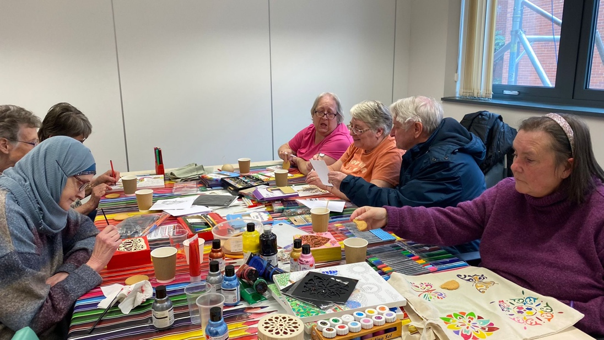
Craft Group

In addition to running activity groups, Wellbeing Champions provide extra 1-1 support to those who needed it. Demand for 1-1 support has steadily increased since DWB reopened post-lockdown, with Link Worker referrals increasing by 64% between the reporting year 2020-21 and 2023-24.

Wellbeing Champions - Supporting Community events
Wellbeing Champions provided over 4000 hours in the local community and reached hundreds of local people by supporting events to share information about DWB’s services and signpost to other services.

- Sheffield Olympic Legacy Park events - running the DWB information stall, speaking to parents whilst children did crafts. 2 volunteers with sports leadership training helped to run dodgeball and chairobics activities for adults.
- DWB information stall at 2 annual Waterfront Festivals, reaching around 500 local people.
- Health & Wellbeing events
- Cost of living events.
- International Roma Day event
- Collaborative Conversations events in Darnall and Tinsley.
- Community Covid Memorial events:
  - Darnall Covid Community Memorial video - link
  - Tinsley Covid Community Memorial video - link

Wellbeing Champions - Supporting children young people and family events
- Wellbeing Champions supported Healthy Holidays activities over several years. These activities are free to children who qualify for means-tested free school meals, and volunteers provided support at sessions offering sporting activities, crafting and Science Technology Engineering Maths (STEM) activities.
- DWB’s information stall and activities at Park Academy's International Community Day in 2023.
- Wellbeing Champions supported numerous local school fairs.
- The Wellbeing Champions helped to pack and deliver over 500 food hampers as part of Healthy Holidays.
- A family picnic in High Hazels Park
- “Say and Play” to help people in the community with improving toddler speech development.

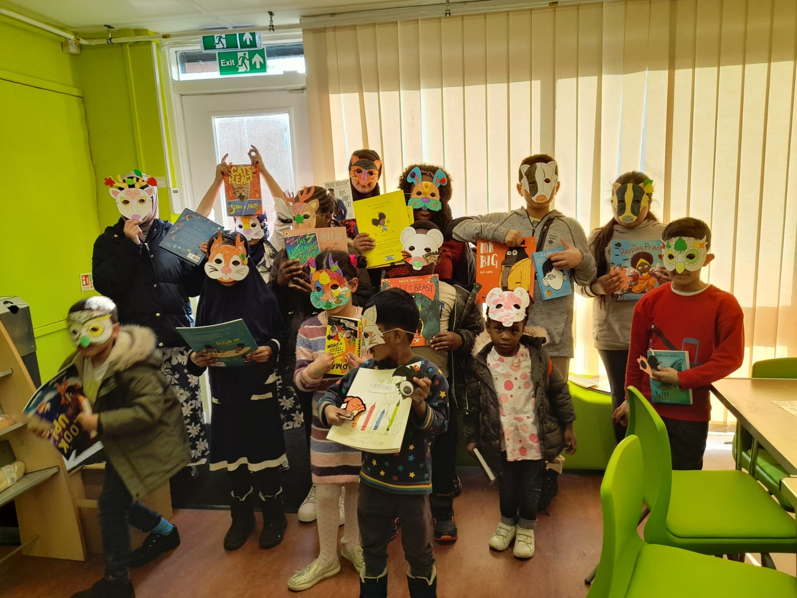
Children’s activity group

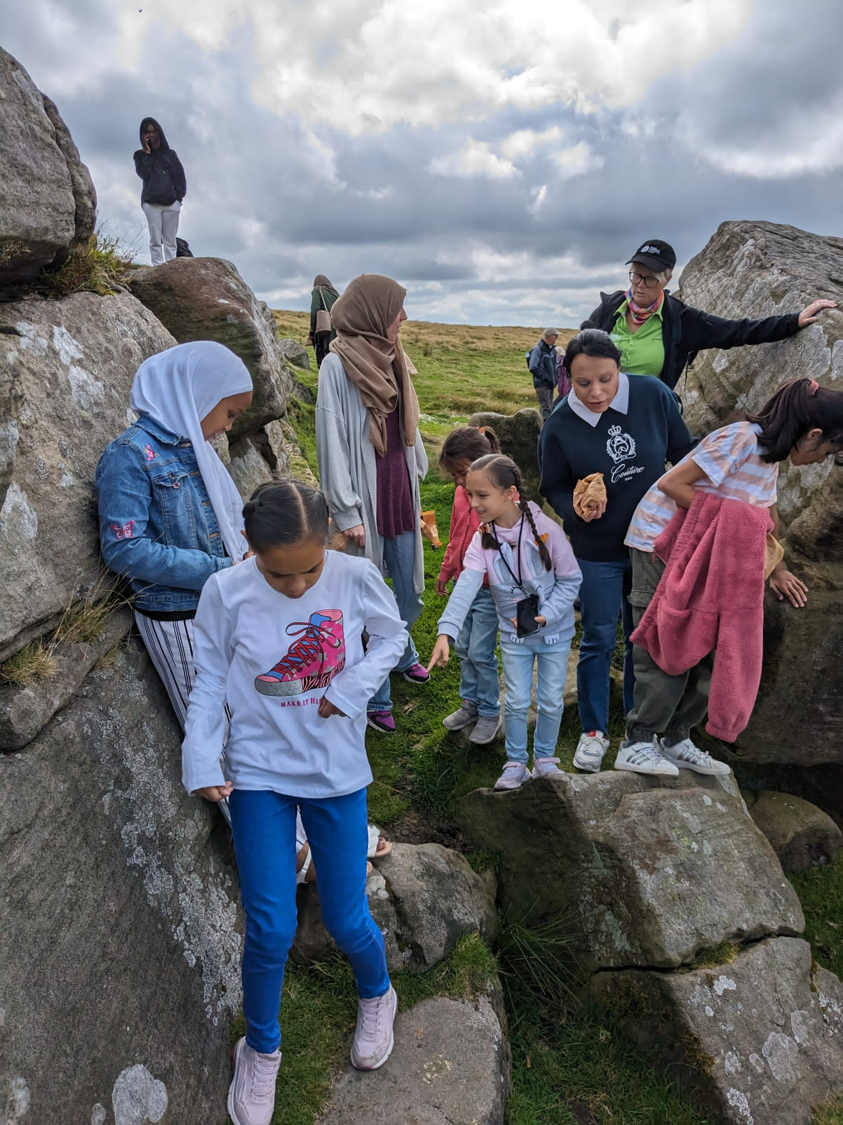
Trip to the countryside

Wellbeing Champions - Activities during Covid 19 pandemic
Whilst a range of planned in-person events and activity sessions were cancelled because of the pandemic, DWB were creative in their response and provided alternatives, for example:
- Mind art therapy sessions – activity packs were created instead of in-person meetings, with Wellbeing Champions providing ideas for packs and distributing them to the community.
- Community allotment sessions - beneficiaries were sent sunflower seeds instead of meeting. 19 people planted them and reported back on progress.
- Over 20 volunteers worked with DWB and other organisations to share a variety of health messages and promoted COVID initiatives in the local area:
- 10 volunteers provided support at the Covid bus and at local food banks, providing information about testing and vaccines. They supported local pop-up vaccination clinics: interpreting, welcoming the public and helping set up.
- 2 volunteers promoted Covid good practice at a local mosque in partnership with Sheffield City Council’s iVan, interpreting, giving out information leaflets and talking to the general public.
- Wellbeing Champions helped put together and write a DWB newsletter and delivered leaflets locally to advertise DWB support.
- A Wellbeing Champions’ WhatsApp group provided two-way communication for sharing information and questions/needs from the community throughout lockdown. The group enabled volunteers to raise questions about Covid misinformation they were hearing locally, particularly around vaccines. This was also used for the city’s Public Health communications.

Wellbeing Champions - Supporting DWB and local organisations
- Wellbeing Champions took part in a network event for local community organisations to share good practice and enhance their volunteering programmes.
- Wellbeing Champions have also taken part in hosting many visitors to Darnall Well Being, sharing their stories about the impact that DWB and volunteering has had on them. These included the Chief Scientific Adviser for the Department of Health and Social Care, the Head of the Government’s Mission Delivery Unit, South Yorkshire ICB, Business In the Community, Good Things Foundation and the Kings Fund.
- The Communication Coordinator established a communications & marketing network for 40 other VCSE organisations across the city – the Sheffield VCS Communications Group - which meets to share learning, good practice and information on fundraising, marketing and communications.
- Wellbeing Champions were involved in planning DWB’s Annual General Meetings, taking part in the planning committee and speaking at the events. Wellbeing Champion, Zoyah, wrote blog posts for the DWB website reflecting on the AGM and on the importance of suicide prevention awareness: https://darnallwellbeing.org.uk/blogs/dwb-agm-october-2022/ https://darnallwellbeing.org.uk/blogs/suicide-awareness-event/

Peer Mentors
The Peer Mentors were experienced volunteers who provided teamwork, buddying and support to newer, less experienced volunteers and allowed DWB to recruit volunteers with less confidence and fewer skills. The Peer Mentor role also provided some individuals with progression into leadership roles or paid employment.
5 Peer Mentors were initially inducted in 2019 with 3 new Peer Mentors later identified to provide informal support to the Wellbeing Champions.

WELLBEING CHAMPIONS PROGRAMME - OUTCOMES

LOTTERY PRIORITY 1. Bring people together and build strong relationships in and across communities.
Planned Outcome:
Strengthening community cohesion by bringing people together who might not otherwise mix, to share activities, leading to increased mutual understanding and cultural awareness.

Results
Interviewees described taking part in the activities with people from widely differing backgrounds helped them build understanding and develop friendships and meaningful relationships that they wouldn’t otherwise have done.

Several interviewees talked about riots in the summer of 2024 and described their fear and anxiety regarding children and young people leaving the house and possibly being attacked. They themselves were too afraid to leave the house. DWB provided a summer weekly drop-in for a mix of attendees and when the riots occurred DWB staff prompted conversations about how people felt and discussed the violence. These meetings and conversations helped to allay people’s fears and strengthen community cohesion at a time when community relations were extremely strained.

“Before I came to DWB I had never spoken to a woman in a headscarf”.

The Chairobics group is the highlight of my week it gets me out of the house I come a long way but it's worth it I have a laugh a meet lots of different women from different communities different ages and different abilities.

I've met people from different communities and made new friends; it helps my mental health because when I talk it's like therapy. English conversation group attendee

I come to the group to find new people and to socialise with local people and hear about their life experiences I share and gather their life experiences. English conversation group attendee.

I've lived locally for a long time but didn't know anyone or what was in the community but now through volunteering I bump into people I know when I'm out shopping.

I've learned how to help other people in the community

Volunteering positively impacts on the community and positively impacts on me.

“I’m so proud that in this area we have this organisation which supports the whole community”.

LOTTERY PRIORITY 2. Enable more people to fulfil their potential by addressing issues at the earliest stage.

Planned Outcomes for Wellbeing Champions:
- Wellbeing Champions progress into education or paid employment, meeting their economic potential
- Wellbeing Champions experience improved quality of life, with improved social connections, a sense of purpose and belonging, encouraging active citizenship

Results
1 - Wellbeing Champions progress into education or paid employment.
- Five Peer Mentors progressed to paid employment with DWB, as well as continuing to act as Peer Mentor volunteers.
- Wellbeing Champions Saada and Harkesh, interviewed for this evaluation, progressed into paid employment as sessional support workers. https://darnallwellbeing.org.uk/home/case-studies/saadas-story/
https://darnallwellbeing.org.uk/hs-story/
- One Peer Mentor went into paid work in health and social care.
- Volunteering provided Teresa with the experience and skills to become a trustee on the DWB Board: https://darnallwellbeing.org.uk/teresas-story/
- Two Wellbeing Champions took part in a co-produced research project with Sheffield Hallam University into Social Prescribing and Frailty; an independent research project to develop research skills, undertake research, analysis, report writing and dissemination. Both volunteers completed the Community Researcher training and conducted qualitative research as part of the training.
- Mags is a Wellbeing Champion interviewed for this evaluation who has been volunteering in the DWB office providing general administrative support and inputting to the new Customer Relationship Management (CRM) database. Maintaining and enhancing her IT skills through volunteering. https://darnallwellbeing.org.uk/home/case-studies/kms-story/

“Becoming a volunteer was life changing for me. I was shy and didn't go out much I wasn't sociable. When I became a volunteer I met lots of people, learned about the community. I didn't know any local parks shops gyms and now I've discovered a lot of places. Volunteering built my self-esteem and confidence - now I can stand in front of a big group and speak. At first it was a big challenge, I was shaking.
I got into volunteering after I was referred to the DWB Health Trainer as a client. The Health Trainer encouraged me to volunteer to translate for the diabetes group. I was scared -it was a big responsibility, but I've done lots of training lots of training and I got lots of support. Now I'm a paid worker. I've come a long way!” Saada

Volunteering has given me experience of working in an organisation that I didn't have before. I've learned about relating with other people, colleagues and people attending the activities. I've learned about time keeping and work ethics and values. It's provided personal development and professional development with lots of training opportunities.

Volunteering gives me opportunities I wouldn't otherwise have.

2 - Wellbeing Champions experience improved quality of life, improved social connections, a sense of purpose and belonging.

Results
Wellbeing Champions talk about what they get from volunteering with DWB: https://youtu.be/LveESOY_dPI?feature=shared

Wellbeing Champions feel they use their skills and knowledge to benefit the local community, creating a ripple effect into the community by sharing health information and support with their families, friends and neighbours.

All Wellbeing Champions interviewed described the same powerful effects of volunteering on their mental, emotional and physical health and wellbeing:

- more connected to the community,
- a sense of belonging,
- increased purpose and direction.
- making new friends and meeting new people from a range of backgrounds,
- helping them to feel less isolated and lonely,
- feeling valued,
- having increased self-esteem, confidence and wellbeing.

Volunteering has definitely helped me feel more confident and have greater self esteem. I feel more in control of my life.

Volunteering is really good for my mental and physical well-being the volunteer coordinator and communications coordinator and the whole Darnall Well-being team are very supportive. I have dyslexia and dyspraxia and they helped me to learn at my own pace.

I love volunteering here. I feel part of a team. I have made new friends.

“Volunteering at Darnall Dementia cafe is possibly one of the very best things that's happened to me I feel I have purpose and direction support like I have never felt in any work I have done before.” Volunteer at Happy Memories Dementia Café.

“I have a new set of people to socialise with and it stops me becoming isolated at home. This is hugely important to me, because I recognise within myself that my anxiety increases the more I stay at home. I really enjoy the feeling that I can at least make a bit of difference by supporting others and, at the same time, I also receive some support in return. For me, volunteering is definitely a two-way thing, and you get out of it as much as you give. I find that hugely satisfying.” Teresa

Planned Outcomes for Beneficiaries:

- Reduce isolation and loneliness and support mental wellbeing
Reflecting the high levels of social isolation and loneliness in Darnall, the overriding theme of every interview was that attending groups got them out of the house where they felt isolated and lonely, with resulting poor mental and physical health and wellbeing. This was stressed by every interviewee. For many it was the only time in the entire week when they left their house.

We women stay in the house all day. All we do is cook and clean. I feel isolated and lonely with no one to talk to all day. It gets worse and worse. I think I'm going mad. So this group gets me out and I have someone to talk to.

I come out of my shell. The group helps me build my confidence to go to other groups and classes.

The group helps with my isolation it helps me socialise

I can talk about problems such as the menopause - we don't get to talk to anyone else about it.

The only time I ever go out of the house all week is to come to this group.

- Encourage healthier lifestyle choices e.g., moving more. individuals better manage their own and their family’s health.

There are higher levels of disability, physical inactivity and long-term illnesses such as diabetes in Darnall than in Sheffield or England. All beneficiaries interviewed described how attending the DWB groups and being supported and encouraged by volunteers from their own communities, supported their health and wellbeing, encouraging them to adopt healthier lifestyles and seeing the benefits in terms of reduced medication, better control of their blood sugar and weight loss. They also described further benefits in terms of sharing their learning with their families.

I learn exercises here and then I practise them at home.

I'm diabetic and the group helps me manage my sugar levels.

I really enjoy the Chairobics group is better than going to the gym because I can talk to people; it is relaxing physically and mentally.

It would be a real loss if we didn't have the Chairobics group it soothes my aches and pains and I look forward to coming.

The conversation group has given me better English, it has lots of benefits and will help with my future career

The conversation group helps my English, helps make new friends and learn new things; I'm new to England - from Bangladesh.

Can you provide some activities and support for our kids?

Janet’s story

I tripped and landed heavily on my left hip and shoulder. I was in so much pain I thought my leg was broken. More severe pain was to come from my back which travelled down my left thigh and into my calf. I could not stand without support or walk upstairs.

That is when I was referred to Waqas and Eram for support. Waqas asked me if I knew about Darnall Wellbeing activities and groups. Activities like Pain Support Group, Yoga, Chairobics, organised Walks in the local park.

Pain Groups are invaluable as people who are in severe pain day after day can talk about their illnesses and the problems these cause them in their day to day living. They can talk through their anxieties openly and connect with other people who have the same problems.

As the pain started to lessen, I realised that the rest of my body wasn’t getting any exercise. I browsed a Darnall Wellbeing flyer and booked a slot on the Tuesday morning Chairobics. This exercise would allow me to exercise my body while still sitting on a chair. The chair would take the weight of my body not my back or legs. I was impressed. I decided to give it a whirl.

This was my first step through the doors of the Darnall Well Being Centre. I look back and liken the experience to that of Judy Garland as she stepped through the portal into Emerald City.

As I started to get stronger, I went for walks around High Hazels Park led by Joanne. The other patients of Darnall Wellbeing who came on the walk proved to be good company.

As time went on I became involved in other activities: Trips to see artists’ work. Tapestries in Sheffield Cathedral. Mixed sessions in the community room where other people could talk freely about their health problems, especially in the pain groups, and Public involvement in the Research Group at Advanced Wellbeing Research Centre.

What I didn’t find on the flyer was the staff who work there. The staff who keep me going to the Darnall Wellbeing Centre.

Joanne’s Walks through High Hazels Park, Waqas who is always smiling and helpful. Alfred who is a wonderful spirit and the volunteers who hand out the drinks of water during Chairobics and fresh fruits for those who want them. Without these people Darnall Wellbeing would not be the same. They keep me coming week after week.

LOTTERY PRIORITY 3. Improve the places and spaces that matter to communities.

Planned Outcome
1. Improve digital space to build social connections and digital inclusion
- Create a vibrant social media page to engage the community
- Wellbeing Champions develop their digital skills and become involved with social media and other publicity to engage with the community.
- Deliver high quality engaging and impactful communications to promote the work of DWB, its Wellbeing Champions’ programme and activities to a wide range of stakeholders and communities.

Results
1. Building social connections
A Communications Coordinator was recruited as part of the Wellbeing Champions programme to develop the digital space and to build strong communications and community connection. This was a hugely successful role which built the profile of DWB and its services and groups, ensuring a far wider reach into the community than had previously been achieved.
- A DWB presence on 3 social media platforms and extending an existing 4th Platform. Social media profiles have grown to 4000 followers, with 2,000 tweets with 20,000 engagements, and 1,000 Facebook and Instagram posts with over 8,000 engagements
- A new DWB YouTube channel, sharing 70 videos with over 4,250 views, raising awareness about DWB services and the volunteer programme, as well as Covid safety and vaccines DWB videos
- A new DWB website, launched in May 2020, to provide details and booking arrangements for the range of activities and events on offer, as well as information on a wide range of health issues and support groups available. Darnall Well Being
- Wellbeing Champions contributed ideas, articles and translations of key messages for the new Community Connector’ newsletter. The newsletter includes information about DWB activities, local services, businesses, events learning opportunities and support, as well as important health and wellbeing information; the Winter 2024 edition for example includes an article about Mental Health and Well-being within the Muslim community.
The first 3 editions delivered to all 8,300 households in Darnall ward. It is also available from GP surgeries, libraries, cafes and community organisations and can be read online: DWB Community Connector Newsletters.
- 1,000 different flyers and other designs, which can easily be shared online or printed (without being ink-heavy), to make information accessible to people who cannot, or choose not to, access information online
- A new weekly email update, sent to 150 local people and groups, and local WhatsApp groups reaching over 500 local residents, with Information about DWB and other local services.
- A new bespoke Customer Relationship Management (CRM) database enables accurate recording and reporting of activity registers and service user data. It provides a picture of the support taken up by DWB’s service users, evidencing the journeys of beneficiaries, e.g., from an initial 1-1 referral, through to attending groups, to becoming a volunteer and then accessing paid employment or other life opportunities

2. Tackling Digital Exclusion
At a time when much of life is accessed and organised online, many local people face digital exclusion with limited or no internet access and unable to afford a mobile phone contract. Many have no or low levels of digital skills, further compounding the digital exclusion they experience.

The Communications Coordinator supported Wellbeing Champions to play a key role in increasing digital inclusion in the community:

- Wellbeing Champions were trained to be ‘Digital Wellbeing Champions’ and provided with laptops to support local people to gain digital skills and confidence. They supported weekly digital drop-in sessions at DWB’s Welcome Places sessions.
- DWB joined the National Databank, set up by the Good Things Foundation (national digital Inclusion charity) to tackle data poverty and isolation, which provides mobile data to people who cannot afford internet access.
- DWB sourced 9 laptops from Laptops For All with data for local people who had limited internet access and helping them to get online
- DWB signed up with the Good Things Foundation to be an Online Centre and promoted the training on the DWB website and through the DWB team.
- A Digital Volunteer group was set up to share information and questions/needs from the community.
- 3 Wellbeing Champions met with Good Things Foundation in 2023, to help with user testing their new Learn My Way online training system.
- As part of DWB’s wider role in representing the local community to other services, the Communications Coordinator joined NHS South Yorkshire Integrated Care Board’s Digital Research and Innovation System Delivery Group and contributed to research on digital exclusion in healthcare with Dr Paulina Ramirez at the University of Birmingham.

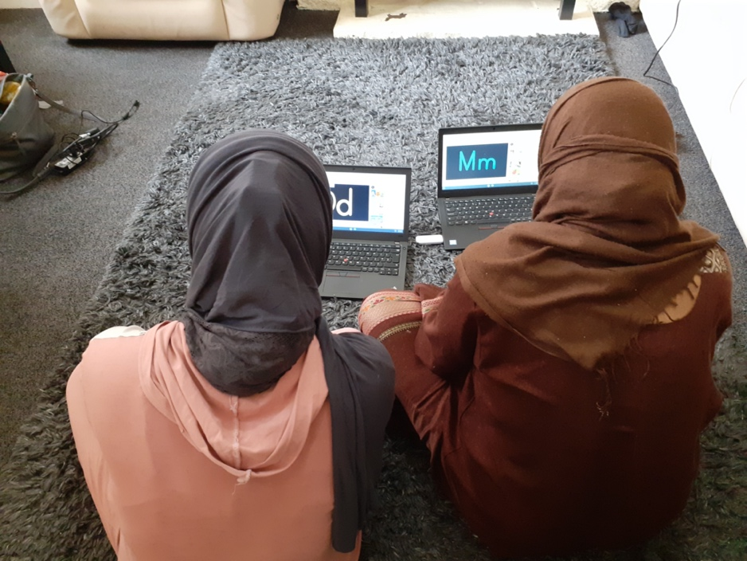
Laptops for All

2. Improve physical space - Improve the local community environment

Results
Wellbeing Champions staff the Welcome Desk in the waiting area of Darnall Primary Care Centre where DWB is based. Seeing an approachable person from their community, who can also help with translation and interpreting if necessary, enables people to feel comfortable attending the practice and accessing a wide range of information and leaflets about DWB and local activities and support.

Volunteers and beneficiaries worked to improve the local environment by taking part in the DWB allotment project which aims to improve health and wellbeing and promote community involvement and social inclusion in the area. Regular sessions are held on the site with an emphasis on social activity whilst improving health and wellbeing. Volunteers help out with tasks around the plot and are encouraged to take home fruits and vegetables from the allotment.

In addition to improving their local community environment, Wellbeing Champions enabled service users to visit different places of natural beauty in the parks and countryside. For many of them this was a new experience.

We went to the Peak District. I have never been to the countryside before and never been hiking I loved it.

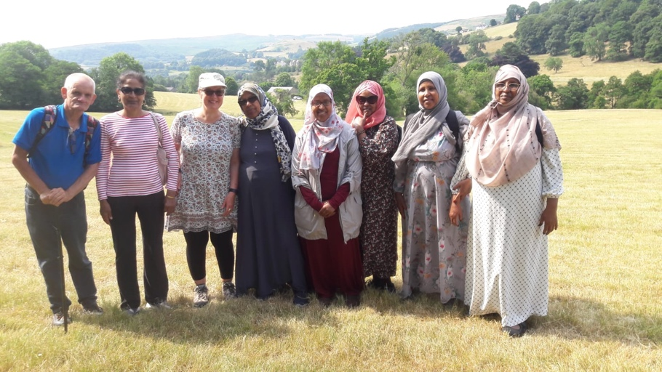

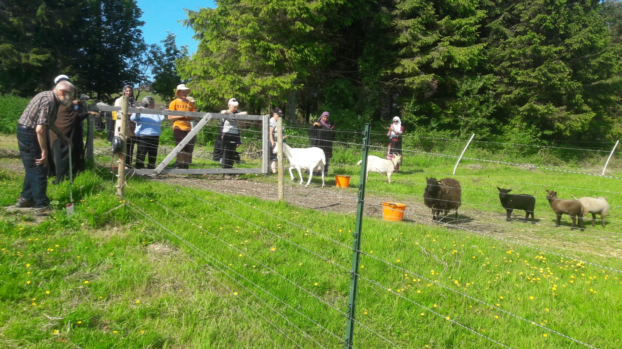

KEY SUCCESS FACTORS

Darnall Well Being - 20 years of experience in the local community
DWB is an established local anchor organisation with very strong connections with and an understanding of the needs of the local community, including groups who are socially isolated, digitally excluded and non-English speakers. It is known and trusted by local people. DWB builds trust by employing local people as staff and volunteers and by listening and responding to local need. 15 Community Researchers from the local community were trained to provide insights into the needs of the communities and inform the design of DWB’s activities and services. Volunteers and service users are engaged in the planning and delivery of DWB and other local services.

Values
DWB and the Wellbeing Champions Programme use an asset-based approach, which believes that as well as having needs and problems, the communities also have social, cultural and material assets and that individuals can become active agents in their own and their families’ lives.

Local people
Recruiting staff and volunteers from the local area was one of the keys to the Programme’s success because they were able to build the trust needed to engage local people to attend activities, build their self esteem and confidence and connect them with other people and services in their local communities. Recruiting volunteers from a wide age range and at least 11 different ethnicities further ensured people felt comfortable and supported when attending activities and had access to interpreting as necessary.

Training And Skills Development
The Wellbeing Champions were provided with year-round training programmes and time-tabled inductions. 17 courses ranging from the Introduction to Community Development & Health course - x 6 sessions (15 volunteers), Dementia Friends training (60 volunteers), Community Champions training (19 volunteers), Community Sports Leadership Level 2 (7 volunteers), Emergency First Aid at Work (26 volunteers), to Mental Health First Aider 2-day training (5 volunteers), Suicide prevention (5 volunteers).

“All the training I've had as a volunteer has given me the skills and confidence to do certificated Envisage training to level 4.”

“Volunteering helps me retain my skills develop new skills, partly through the training courses I have been on, and partly through staff teaching me.”

Volunteers also had quarterly meetings to get to know one another better, share experiences and knowledge and hear about training and other opportunities.

Celebrating Wellbeing Champions
The Wellbeing Champions were celebrated and their efforts recognised at an annual Celebration event for volunteers, with everyone being presented with certificates and thanks for their hard work and commitment.

“The celebration events make me feel very valued. They recognise what we contribute and we get a certificate”.

Volunteer Coordinator
The Volunteer Coordinator role has been vital in recruiting and supporting the 40+ Wellbeing Champions and Peer Mentors and enabling them to successfully run a wide range of activities for local communities. Wellbeing Champions and Peer Mentors also contribute significantly to service design using their expert knowledge of health conditions and understanding of the barriers people can face.

Volunteers come with very different life experiences, skills and expertise. Some may have experience of paid employment but be new to volunteering, others may have no experience of paid work, while many have lived with long term mental or physical ill health. The roles the volunteers fulfil and the support they need therefore varies greatly between individuals. The Coordinator has been crucial in the recruitment and induction of volunteers, matching individuals to different roles taking into account their needs for support and their level of skill and experience. The Coordinator managed group dynamics and provided ongoing support and pastoral care, for example running regular group supervision sessions. Long term pastoral support was needed for vulnerable volunteers facing additional barriers to engagement and needing time to grow and develop.

The Volunteer Coordinator also managed the complicated logistics and dynamics of the Wellbeing Champions delivering a wide range of activities across many sites and venues, often troubleshooting and filling in at short notice. Managing the Activities Programme provided a consistent approach across the sessions and ensured the Wellbeing Champions were matched to particular activities and the needs of group attendees.

“DWB has looked after our welfare and well-being as volunteers”
“The Coordinator is always there to help if we need it’

“The Coordinator helps us to come together and unlock our potential”

“The Coordinator runs support groups for us volunteers, which are so helpful’.
Communications Coordinator
The Communications Coordinator has transformed DWB’s digital presence and communications and delivered high quality engaging and impactful communications to promote the work of DWB, its Wellbeing Champions’ programme and activities to a wide range of stakeholders and communities. The Coordinator has led the development of volunteers’ digital skills, supporting them to become involved with social media and other publicity.

“Having a dedicated Volunteer Coordinator and Communications Coordinator role has had significant impact on the Wellbeing Champions Programme. We see these roles as key in supporting our communities to come together and in unlocking their potential.” DWB CEO

CHALLENGES

Impact of COVID19 pandemic
The severe impact of Covid 19 and the restrictions placed on DWB and its communities cannot be underestimated. DWB had to close their offices and enable staff to work from home from March 2020 onwards. The Wellbeing Champions programme had to be put on hold. All in-person groups and support were cancelled and the recruitment of volunteers halted, only gradually resuming once activities began to reopen.

Throughout lockdown DWB kept in touch with their volunteers by phone, WhatsApp messages and email updates, however regular in-person supervisions and meetings were not held during the period as many were vulnerable to Covid and/or had caring responsibilities impacting on their available time. While volunteers could not meet in person during lockdown, DWB held some online meetings, however many volunteers could not use online meeting platforms because their digital skills were at that time still limited. Later in the pandemic, regular meetings were held online and in a local park allowing volunteers to stay connected, share stories, remember the importance of the work they were doing and enabled DWB to ensure that those who needed it were given individual one to one support.

The pandemic also led to a number of staff changes resulting in a temporary vacancy for the Volunteer and Activities Coordinator post. Whilst DWB did their best to manage the volunteer programme during that period, the experience demonstrated that the programme could not run successfully without a dedicated Volunteer Coordinator to manage it and provide support to the volunteers.

CONCLUSION

This report provides an independent evaluation of the Wellbeing Champion programme, describing both the activities and the outcomes of the work.

The evaluation shows that the programme achieved its planned outcomes and the National Lottery Priorities, providing significant benefits for both volunteers and beneficiaries and helping to address many of the problems experienced in Darnall, particularly social isolation, loneliness, ill-health and digital exclusion.

As a result of the activity groups, one to one support and culturally tailored information and advice, beneficiaries described feeling better connected, more confident and able to socialise with people from different communities; this in turn helped them feel that their area has a stronger community spirit and cohesion. All described that their self-esteem had improved and reported feeling more in control.
Beneficiaries described an increase in knowledge, confidence and skills relating to getting fit and staying mentally and physically healthy.
Everyone described how the activities and support got them out of the house and helped reduce their isolation and loneliness.

Similarly, the Wellbeing Champions experienced increased self-esteem, confidence, knowledge and skills, together with a strong sense of purpose and belonging.
As a result of the Programme many volunteers were able to get paid employment or went into education or training.

Key success factors of the Wellbeing Champion Programme included the Volunteer Coordinator and Communications Coordinator roles, the comprehensive training and support provided to the volunteers, and recruiting volunteers from the local community, ensuring they were trusted by the beneficiaries.

The Programme helped to remove barriers to health and wellbeing by being local and providing free or low cost, consistent and culturally sensitive activities and events. Many activity groups were provided as women-only spaces.

The delivery of this programme was undoubtedly affected by the COVID-19 pandemic. It is testament to the commitment and passion of the DWB Team and the flexible responsive nature of their services and Wellbeing Programme, that they not only delivered the activity groups and volunteer training programme as described in their Big Lottery bid, but responded to the Covid 19 pandemic with creativity, dedication and skill.

Many interviewees asked for sessions and support for their children and young adults, citing worries about the high levels of unemployment and low levels of qualifications locally.
It is therefore recommended that DWB is supported to continue to deliver its current activity and to further develop this programme to increase the employability of young people.

Acknowledgments
With many thanks to the Wellbeing Champion volunteers, DWB staff and group attendees and beneficiaries for their time, energy and good will taking part in interviews for this evaluation.

