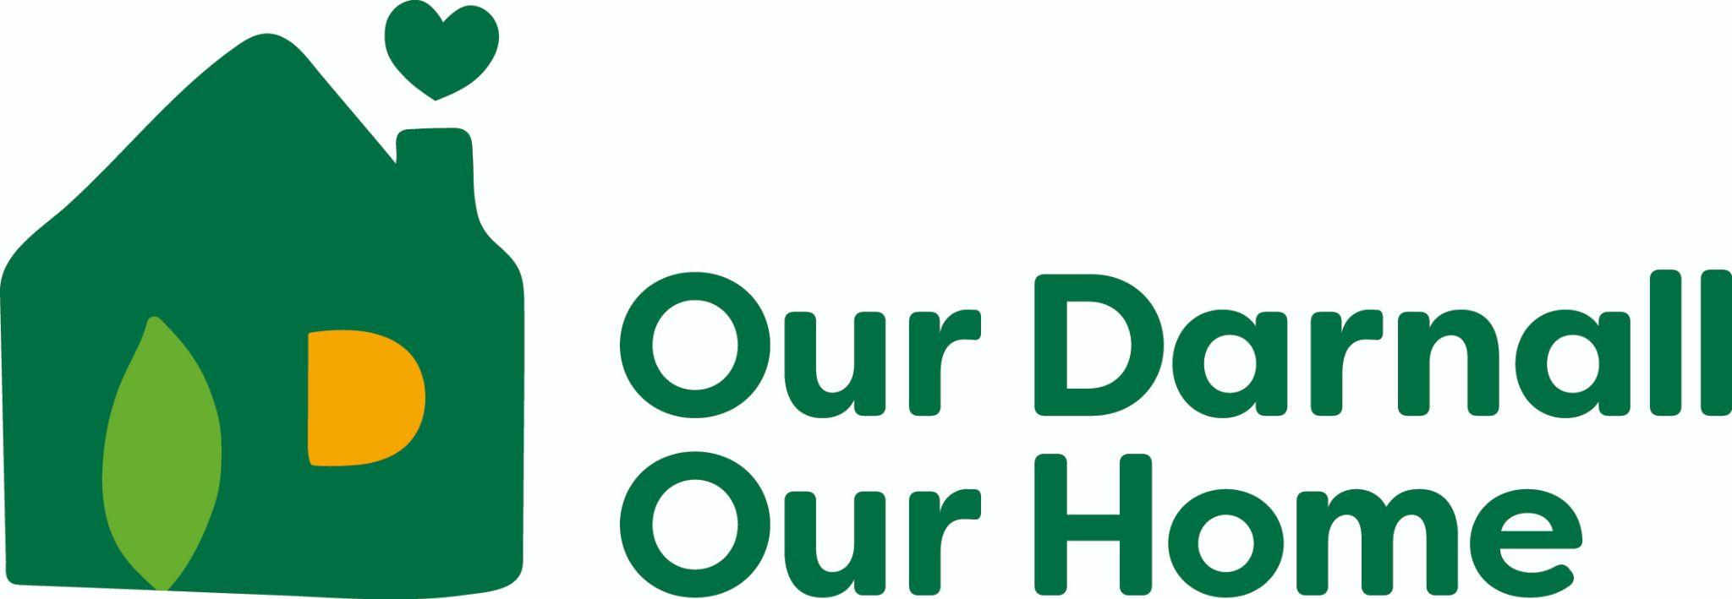

HOUSEHOLDS

Why We Should Keep Our Streets Clean
Protects Nature – Keeps animals safe, stops pollution, keeps our land and water clean
Keeps Us Healthy – Stops germs from spreading and keeps away pests like rats
Makes Darnall Nice – Clean streets look good and make people happy to visit Darnall
Avoids Trouble – Throwing rubbish in the wrong place can lead to fines
Helps the Planet – Recycling saves resources and helps fight climate change!

Ways to Keep Our Streets Clean
- Always use a bin – Never drop litter on the ground
- Join a litter pick or organise your own – Help clean up your local area [Organise a community litter pick | Sheffield City Council]
- Remind others – Encourage friends and family to bin their rubbish
- Recycle – Sort paper, plastic, and cans into recycling bins
- Keep bins closed – Stop rubbish from blowing away
- Report big messes – Tell an adult or the council about litter
- Use reusable items – Bring your own bottle or bag instead of plastic
- Learn and teach – Help younger kids understand why littering is bad
- Make it fun – Turn cleaning up into a game or challenge
- Be a role model – Set a good example for others!

BUSINESSES
It’s great for business to keep Darnall clean and tidy
There’s lots to think about when running your own business. A key thing is how to correctly dispose of waste. This short guide will tell you how.
The benefits for your business
Attracts More Customers – A clean and well-maintained shopfront makes a great first impression, encouraging more people to visit your business.
Avoids Fines and Legal Trouble – Following waste disposal laws prevents costly fines or prosecution, protecting your business from legal issues.
Boosts Reputation – A tidy business shows professionalism, responsibility, and care for the community, making customers more likely to return.
The rules
- Businesses must dispose of waste safely under the Environmental Protection Act 1990
- Controlled waste includes paper, packaging, food waste, cleaning materials, and damaged goods
- It’s illegal to use household bins, street litter bins, or burn waste without a permit
- Commercial bins must not be on the highway
- Waste must be collected by a registered carrier or taken to an authorised site with proper paperwork
- Bin sharing is only allowed if both businesses are listed on the same waste contract
- Businesses must keep Waste Transfer Notes or receipts for all waste disposal
- Waste records must be kept for at least 2 years
- Illegal disposal (fly-tipping, using unregistered collectors) risks fines or prosecution
- Store waste securely to prevent spills, theft, or tampering
- Clinical waste needs special disposal—contact authorities for guidance
- Report businesses dumping waste illegally
- Penalties include fines up to £50,000 and/or up to 5 years in prison!

