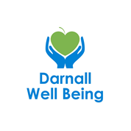 | Darnall Well Being  JOB DESCRIPTION
POST TITLE
Sheffield Children’s Hospital – Family Coach
Darnall Well Being
GRADE
Salary: £24,054 – £26,004
RESPONSIBLE TO
Health and Well Being Manager
RESPONSIBLE FOR
Nil staff
KEY TERMS & CONDITIONS
28 hours per week (DWB has a 35 hour working week)
25 days annual leave & Bank holidays pro rata
8% non-contributory pension
Reflective practice sessions provided
Fixed term 2 year (extension dependant on funding)

PURPOSE OF JOB
The Family Coach will provide early intervention support to families accessing Sheffield Children’s hospital services, who have a range of complex needs, to improve their health, social and emotional wellbeing. Enabling families to access a range of services and activities that positively impact on their wellbeing and build connections within their community. The role will:
- Offer a whole family centred approach to individuals and establish what is important to them, and their wider family networks, including creation of a personalised support plan
- Co-ordinate, simplify and broker access to a range of health and social interventions based on the needs and wishes of the individual, including liaising with Sheffield Children’s Hospital clinical team(s) and a range of agencies (schools, housing,)
- Empower the individual to express their views, wishes and concerns
- Co-produce a personalised support plan that encourages the empowerment of an individual to take control of their own health and wellbeing (‘what matters to me’)
- Connect individuals to local and city-wide services
- Develop close working partnerships with health, social care, housing and voluntary, community or social enterprise (VCSE) organisations.

Background
SOAR, Darnall Well Being, ZEST and Manor Castle Development Trust have come together to deliver a new and exciting 2-year pilot in partnership with Sheffield Children’s NHS Foundation Trust.

The pilot project aims to close gaps in care and simplify access to services that address each family’s unique needs. It is about making support more accessible, adaptable, and well-connected—prioritising families and building stronger community connections across the city with Sheffield Children's Hospital.

A dedicated team comprising a Lead Family Coach and Family Coach will work seamlessly across all three service pathways, ensuring families have access to a comprehensive range of support whenever and wherever they need it. Example(s):
- Support the family to find and register at a dentist
- Work with Citizens Advice Sheffield to ensure all benefits are being claimed
- Ensure the family get travel access support so they can attend health appointments, etc.

Access criteria (the service pathways)
Families will be offered a Family Coach support, predicated on the child or young person being under connected to Sheffield Children’s NHS Foundation Trust either due to:
- Regular attendance at the Emergency Department (ED);
- within the dental extraction pathway, or
- has long-term complex medical needs
- Indication that poverty is directly impacting their health outcomes (seen in food poverty, poor housing, low access/attendance rates, etc)
- Does not require level 4 on the threshold of need scale for safeguarding.

Outcomes
Families supported by the Family Coach are likely to see an improvement in their:
- Confidence and skills to self-advocate and navigate services
- Financial wellbeing through access to benefits and other support
- Health literacy, and self-management of child/young person health conditions.

Outcomes of the wider health system (& beyond) are:
- Reduced ED attendances within the emergency department pathway
- Improved oral health wellbeing within the dental extraction pathway
- Improved school attendance, where this has been identified as a goal.

Areas of Delivery
Each Family Coach will be work within the local community.

Training
The Family Coach will be provided with intensive work shadowing opportunities and package of accredited and non-accredited training, including:
- Health Coaching up to Intermediate level
- Mental Health First Aid
- Personalised Care Institute/E-LFH modules
- Safeguarding level 3 (children and adults)
- Multi-agency training via the Early Help Partnership training offer, i.e. Signs of safety, Early help assessments.
- Mandatory training, includes;, Health & Safety, Data Protection (GDPR) and Equality & Diversity (EDI)
- Other training identified relevant to changes in legislation and good practice

Sheffield teaching hospital will provide:
- Induction covering allied roles, and introduction to clinical teams
- Outcome Star training via Triangle
- Clinical system training (incl. SystmOne/liquid Logic) through Sheffield Children’s NHS Foundation Trust and/or Sheffield City Council
- Working with interpreters & use of telephone-based system(s)
- Other professional development opportunities or mandatory training as would be offered to associated secondary care workforce, i.e. CPR, oral health, etc
Location
Main office c/o Darnall Well Being, Darnall Primary Care Centre, 290 Main Road, Darnall, S9 4QH

Sheffield Children’s NHS Foundation Trust Base
The Family Coach will spend time at Sheffield Children’s Hospital to support clients, attend MDTs and engage with wider clinical team colleagues.

SPECIFIC DUTIES AND RESPONSIBILITIES

One to One Delivery
- Hold a caseload enabling individuals with moderate to high support needs to sustain goals/outcomes according to their personalised support plan (up to 12 months)
- Undertake 3, 6 and 9th month reviews, taking in account progression checks, outcome star assessment tool review and access to services
- Undertake 3-month post discharge catch up call to check in with the family to see how they are progressing or require additional support
- Provide information, advice and guidance to individuals that enable them to access services and activities, which help them achieve increased level of health, skills and wellbeing
- Accompany individuals to health, social care and housing related appointments when needed in order to help resolve issues impacting on their health and independence
- Develop a trusting relationship on a one-to-one basis that provides the individual time to explore ‘what matters to you, either via telephone or face-to-face in various settings including Sheffield Children’s Hospital, home visits and community spaces
- Support family uptake of the Barrier buster fund as an aid to removing barriers to accessing services, i.e. transport costs, etc.

Service Development
- Develop a comprehensive knowledge of wider support services for individuals with varying support needs including but not exclusive to; health, housing, employment, welfare benefits
- Work in partnership with Sheffield Children’s Hospital colleagues, Wellbeing Coaches and other staff, to ensure effective and responsive referral pathways are maintained as part of the multi-disciplinary team offer
- Inform line manager of ways in which local services can be developed to improve the health and wellbeing of the local community

Work with Others
- Offer signposting support and guidance to members of the Sheffield Children’s Hospital colleagues, sharing information on what services are available and how to access them
- Attend and contribute to Child Protection (CP), Child in Need (CIN) and Team Around the Family (TAF) meetings
- Maintain effective relationships with health, social care, housing and VCS workers via regular attendance at team meetings and shadowing
- Attend multi-disciplinary team meetings (as appropriate) to develop relationships with key services, increasing awareness and knowledge of social prescribing and the impact on reducing pressures through partnership working
- Attend quarterly community of practice meetings to build and maintain professional peer to peer support
- To take part in regular team meetings to discuss performance and other related issues
- Have knowledge and understanding of all SOARs Teams and willingness to work across teams to provide support when required

Self-Management & Development
- Ability to work with minimal supervision within appropriate guidelines
- Ability to make decisions to progress own work within appropriate guidelines
- Ability to manage own workload to ensure maximum performance through planning and organizing, with an understanding of when and how to prioritise referrals requiring urgent support
- To participate in supervisions and appraisal process
- To attend regular reflective practice sessions
- Undergo continuous personal development as is required

Monitoring, Report and Evaluation
- Ensure referrals are recorded within clinical systems.
- Utilise SOARs monitoring & information system as a means of recording activity and outcomes
- Capture key information and gather feedback on the impact of social prescribing on health and wellbeing through the Outcome Star assessment tool
- Maintain comprehensive, regular and effective feedback mechanisms with referring Sheffield Children’s clinical team(s) and other appropriate organisations within the social prescribing system
- Assist in compiling reports as and when required for monitoring & reporting purposes

Compliance
- To adhere to company policies and procedures, including confidentiality, equality & diversity, safeguarding, lone working, information governance and health and safety
- To ensure company records and information are kept confidential at all times and stored securely
- To have regard for resources and use responsibly
- To uphold the Staff and Client Services Charter
- To understand the Competency Framework and work using key competencies

General
- Undertake visits within client homes and/or Sheffield Children’s Hospital (as appropriate)
- Alert line manager to any issues of concern including work issues, complaints or concerns regarding individuals
- Any other duties as requested by Managers

PERSON SPECIFICATION
Post Title: Sheffield Children’s Hospital – Family Coach

Minimum Essential Specification | Method of Assessment
 | Application | Interview | Exercise
Skills/Knowledge
Knowledge of local area – North Sheffield
Knowledge of the health, social care, housing and voluntary, community or social enterprise (VCSE) sectors
Knowledge of the processes relating to young people and families at risk, example:
- Child Protection (CP)
- Child in Need (CIN)
- Early Help Assessment (EHA)
- Team Around the Family (TAF)
- Signs of safety
Knowledge of the causes of health inequalities
Understanding of the barriers people face to improving their health
Knowledge and understanding of safeguarding children and vulnerable adults
Commitment to a person-centred approach when co-ordinating and brokering access to services
Awareness of your own limits of skills, competences and responsibilities and work within them
Knowledge and commitment to current Health and Safety and Equality and Diversity legislation
Effective Time Management skills
Effective administrative & IT skills; including knowledge of EMIS/SystmOne/Vision
Experience/Qualifications/Training
Experience of working with families who have complex needs and vulnerable and/or disaffected children with challenging behaviours
Ability to support people going through a major change in their lives
Ability to manage conflict and offer positive ways forward in difficult situations
Experience of working in a multi- cultural environment and of involving clients in ensuring practice is culturally sensitive
Ability to mediate, negotiate, advocate and cope with the unexpected
Experience of working with people experiencing ill health to access services (& remove barriers) within the community
Ability to problem solve and respond quickly and flexibly to new developments and challenges
Ability to communicate effectively both verbally and in writing, with a range of individuals and groups
Ability to maintain client records, monitor activity and record outcomes and learning
Good knowledge of English
Essential
Full UK Driving Licence
Own transport
Approach
Commitment to Sheffield Children’s Hospital CARE values (appendix 1)
Ability to build and maintain relationships whilst maintaining appropriate professional boundaries

Appendix 1. Sheffield Children’s CARE Values
Compassion, Accountability, Respect, and Excellence (CARE):
- Compassion is at the core of our interactions. We listen actively to families, valuing their concerns and experiences. Our goal is to create a welcoming environment where families feel comfortable sharing their needs and hopes and where they receive truly person centred, holistic support.
- Accountability is reflected in our dedication to high standards. By setting clear objectives, regularly reviewing our services, and inviting feedback, we make sure we’re providing consistent and reliable support that families can trust.
- Respect is fundamental to our approach. We celebrate the diversity of the families we serve and ensure each individual’s perspective and choices are honoured in their care.
- Excellence means we’re always striving to improve. We invest in ongoing training, ensuring our team is equipped with the latest skills and knowledge. With our vast expertise in delivering health support across diverse settings, our staff will gain additional insights to deliver exceptional, compassionate care.
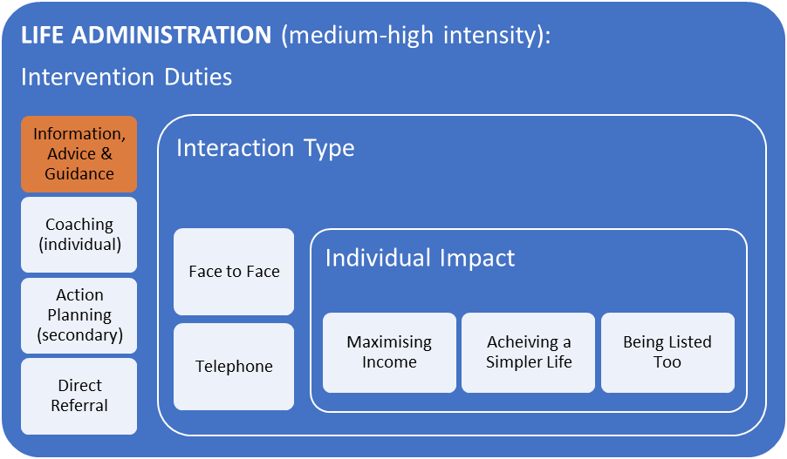
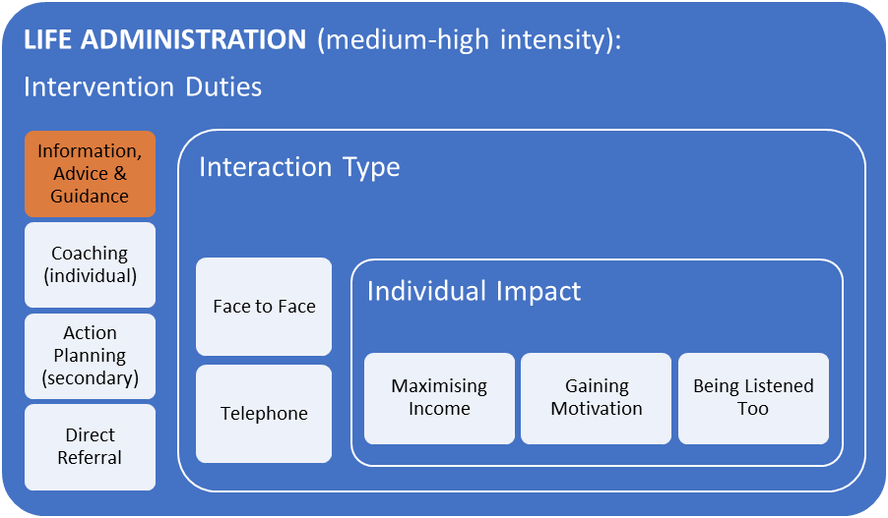
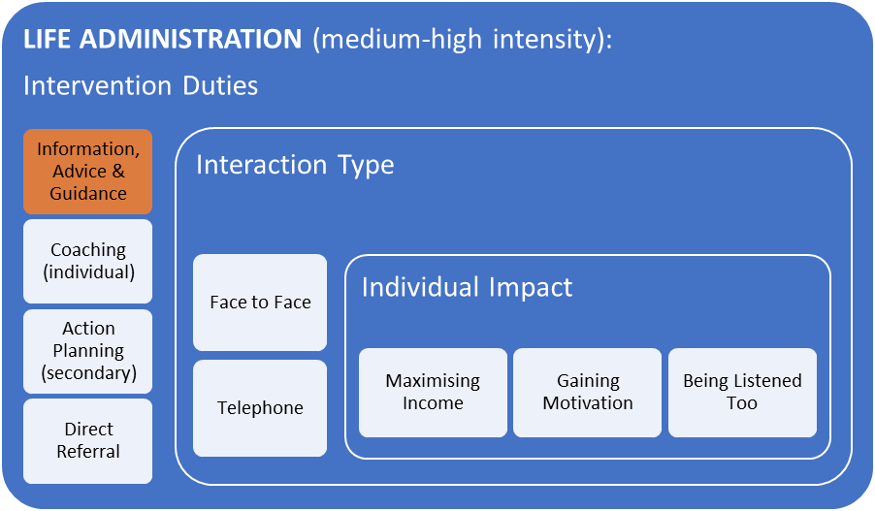
WELFARE COACH

