How to Download Zoom on Your Phone and Tablet Devices
Zoom is an excellent app for starting or joining video meetings with friends and colleagues. Downloading Zoom is an easy and simple process, explained in the following instructions.
Step 1: Find and Open your Store
Every mobile and tablet device has a ‘store’ - think of this as an online shop. There are 2 stores: App Store and Google Play Store. We need these 2 stores to download Zoom.

App Store
Google Play Store
If you are using an Apple device (e.g. iPhone), you will see the blue App Store. If you are using an Android device (e.g. Samsung), you will see the triangle Google Play Store.
Find and click the store on your device. This will open it.
Step 2: Search for Zoom in the Store
Once you have opened the store, you will see a search bar on your screen like this (circled in red so you can see it clearly):
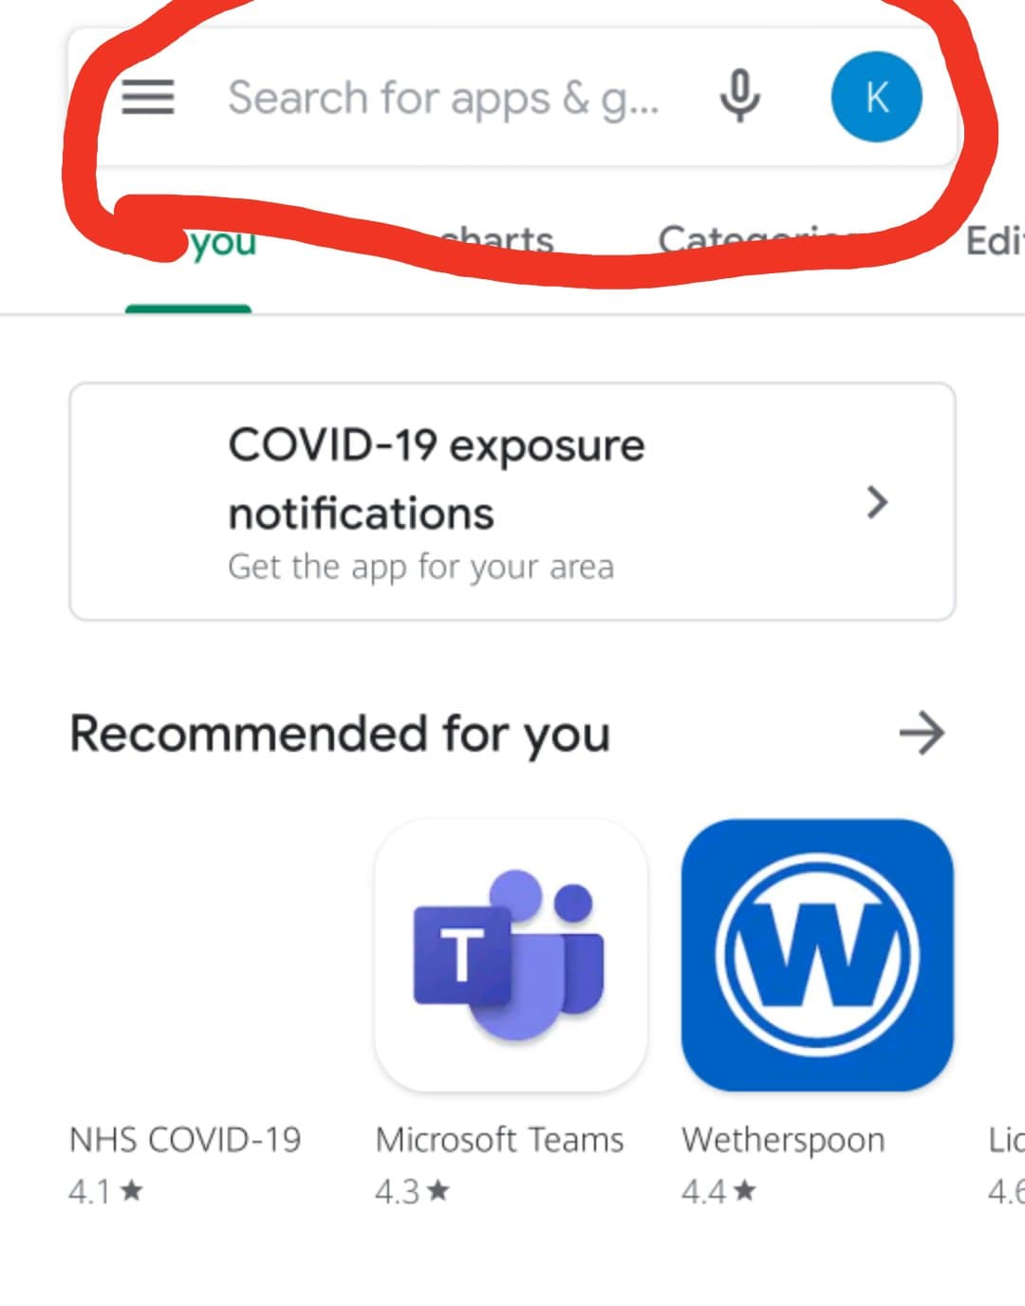

Zoom is a free video call product within the store. To find Zoom, we must search for it. Click the search box, and type ‘Zoom’. Then, click enter to start the search.
Step 3: Install Zoom
On your screen, you will see Zoom as the first search result. It has a blue video camera logo and is officially called ‘Zoom Cloud Meetings’. Click the ‘Install’ button.
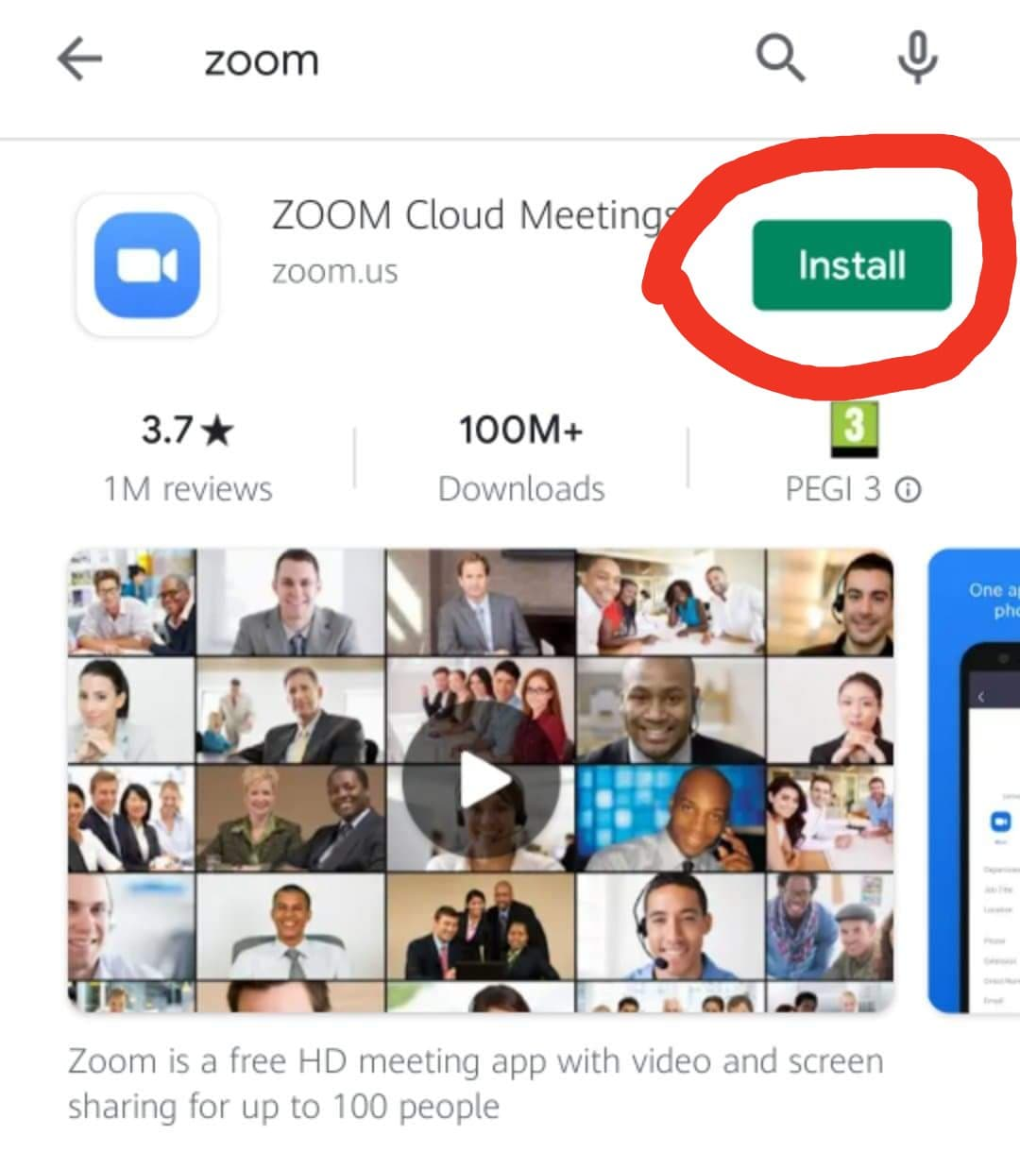

Once you have clicked the install button, sit back and wait for Zoom to download to your device. This should take less than 1 minute.
Step 4: Open Zoom
Once the download has finished, you will see on your screen that the button will now say ‘Open’. Click ‘Open’. This will start Zoom.

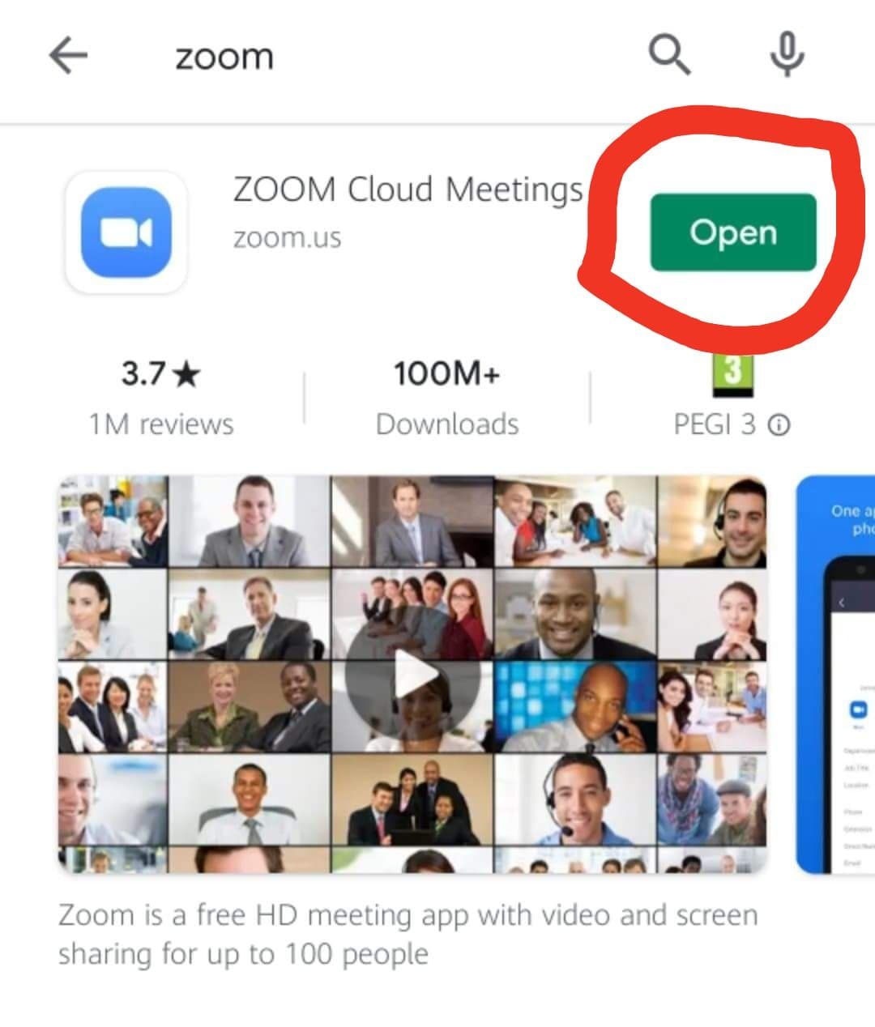

Step 5: Now you Have Access to Zoom
Now you have opened Zoom, you will be able to use it. The picture below is what you will see. There will be an option to start or join a meeting.
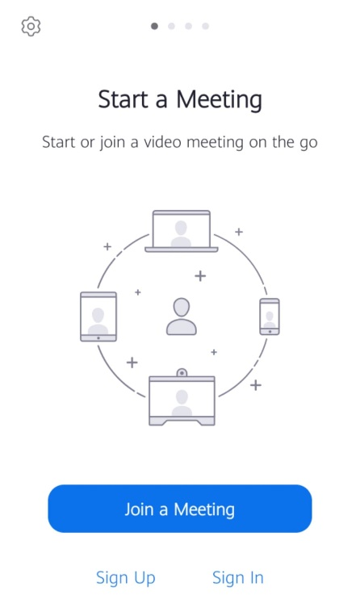

Step 6: Join a Meeting
If you click on Join a Meeting, you can enter the meeting ID and password that you’ve been sent. You can change the name that will be displayed to everyone on the call on this screen, too:
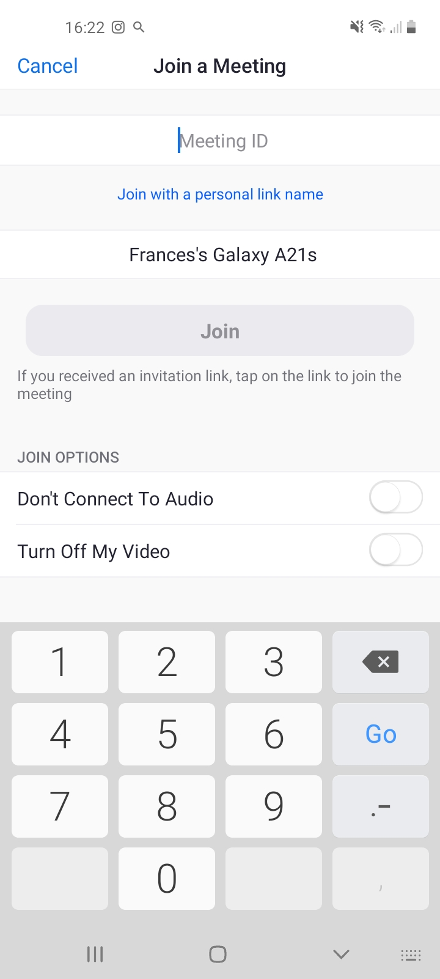

Alternatively, you can click on the link we send you, and it will ask how you want to open the link. Select Zoom and the meeting will open:
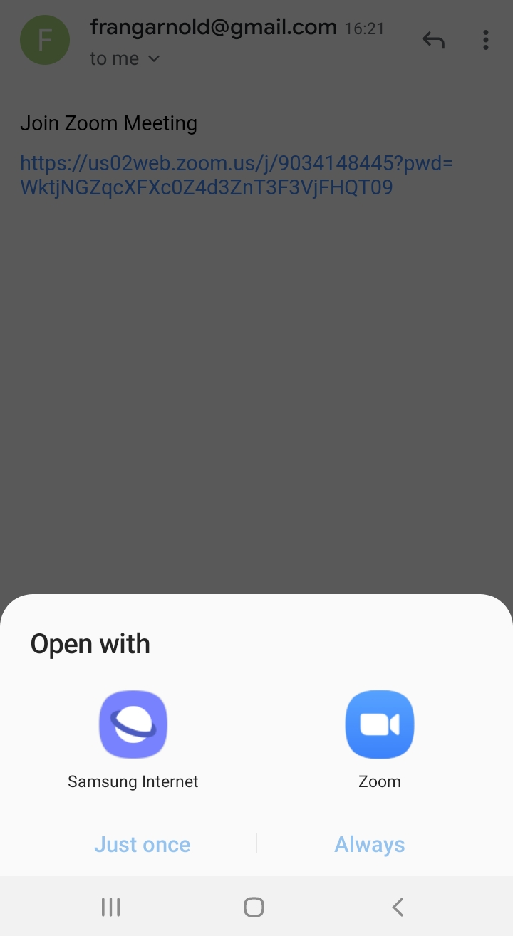

Step 7: In a Zoom Meeting
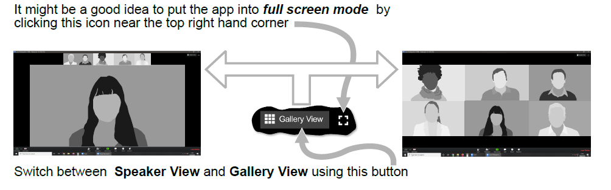

At the bottom of the screen, there are some buttons you can use:
